Ideation Phase
Empathize & Discover

Date | 25 July 2026
Team ID
Project Name | Darshan ease
Maximum Marks | 4 Marks

Empathy Map Canvas:
An Empathy Map helps our team understand the needs, thoughts, feelings, and behaviors of the users of the DARSHAN EASE platform. It enables us to view the temple darshan booking process from the perspective of devotees and temple administrators, allowing us to identify their challenges, expectations, and pain points.
By understanding what users say, think, do, and feel, we can design a secure, user-friendly, and efficient online temple darshan booking system that simplifies ticket booking, slot selection, online payments, booking management, and crowd control. The empathy map helps ensure that the developed solution addresses real user problems, enhances the overall user experience, and builds trust, convenience, and satisfaction among devotees and temple administrators.
The Empathy Map Canvas serves as a foundation for developing features that meet customer needs, reduce waiting times, improve temple crowd management, and create a reliable digital platform for online darshan ticket booking and temple administration.

Example:

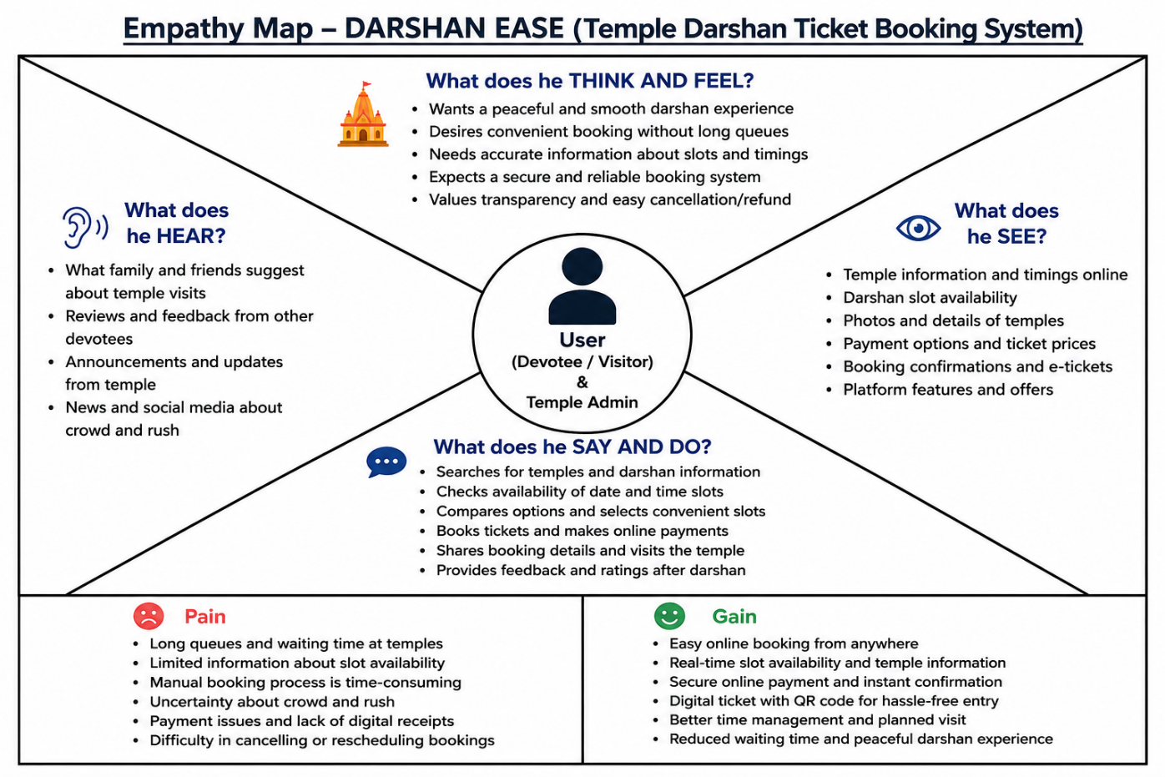

Example: House Rental Application


